INSTRUCTIONS:
(1) Post your comments on Graded MDB & not on Regular Lecture MDB.
(2) Zero marks will be given to Copied or Irrelevant comments.
(3) The comments should be clear and to the point.
(4) Do not participate in the discussion more than once.
(5) You can not participate in the discussion after due date or through E-mail.
(6) Properly prepare yourself about the topic using books or any source available to you.

Topic Detail
“An important in the study of heat transfer is to determine steady state temperature distribution of a thin plate when the temperature on boundary is known. Assume the plate shown in the figure (Click on Picture to see the figure) represents a cross section of a metal beam, with negligible heat flow in the direction perpendicular to the plate. Let T₁, T_{2,} T₃, T₄denote the temperatures at the four interior nodes of the mesh in the figure. The temperature at a node is approximately equal to the average of the four nearest nodes that is “to the left, above, to the right, and below”.

So, using above information, write a system of four equations whose solution gives estimates for the temperaturesT₁,T_{2,} T₃,T₄”

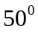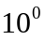

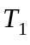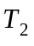
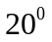

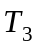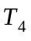

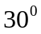

Solution:
To find the linear equations in temperature variables the hint was given in the statement which is the temperature at a node is approximately equal to the average of the four nearest nodes that is “to the left, above, to the right, and below”.
So, temperature at 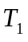node is:
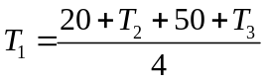
Similarly at 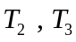 and 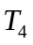node is as under respectively

